Gaming is nothing but really effective communication and education

Common applications:

* Education: code academy; duolinguo
* New product: dropbox
* Training: Nike+; Finger (guitar tutorials)
* For complete profile: LinkedIn -- profile strength

# 

* For using functions: restaurant deal comparison



# Questionnaire

Design avatar (choose gender, age, vocation), customize school badges

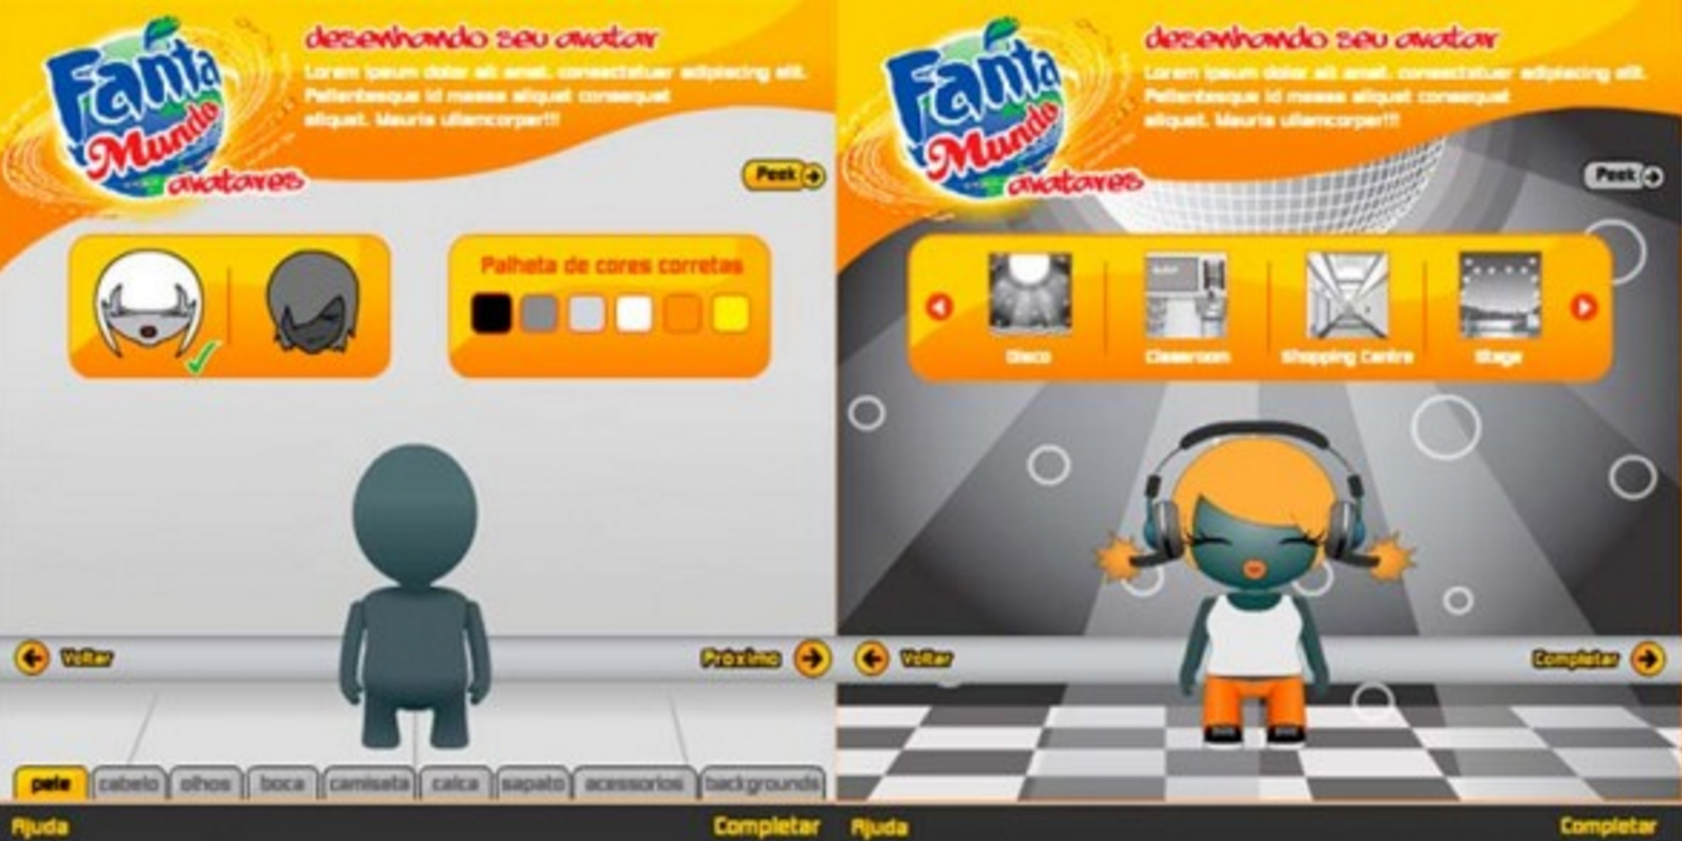

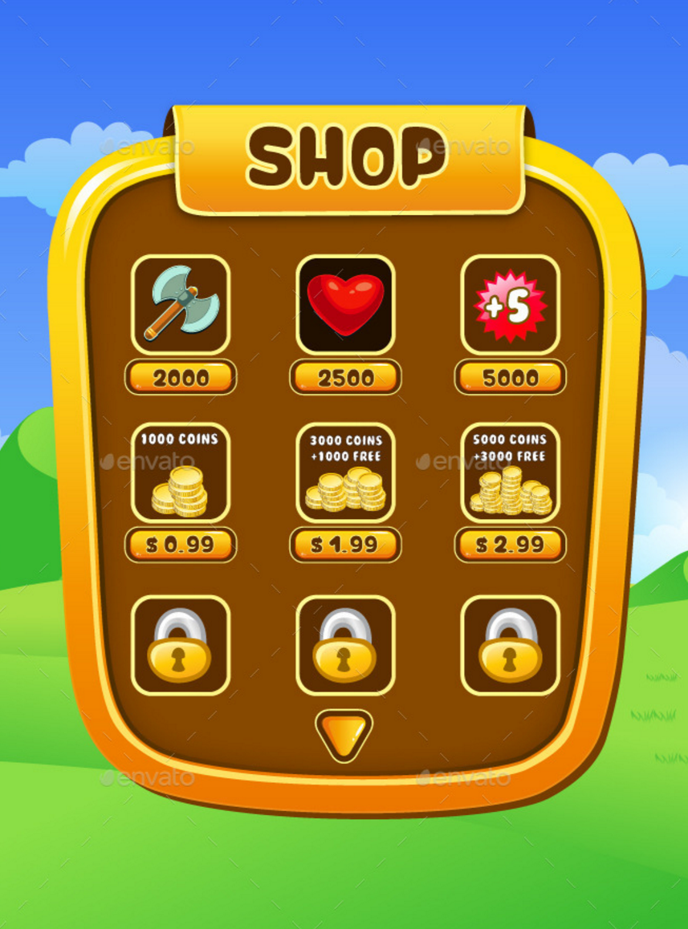

# Application Progress Bar

